PeopleTools Assignment 4

HR 8.8 – NAIT1
Database: NAIT1

Change the Instructor prompt table to only display Instructors that are “Curriculum Developers”. You will need to create a view and insert it in your Course project.

View name: NAIT###_INCD_VW

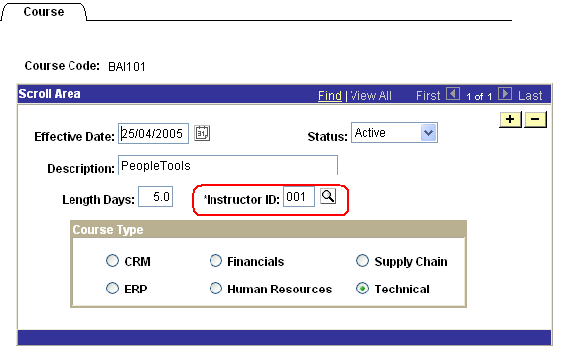

The search page of the view should look like this:
